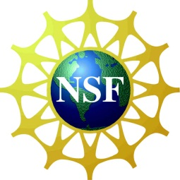
Frontiers in Environmental
Engineering Education

October 18-19, 2012
St. Louis, Missouri

Wednesday October 17th Evening: Social – Brewhouse-Hyatt
6-? PM and Hyatt Courtesy Suite

Thursday October 18th

8:00 Registration opens 18th floor Gateway West
Breakfast

9:00 Welcome and Introductions Joel Burken
State of our Field: Env Eng Education AEESP and Missouri S&T
9:30 Keynote: Undaunted Courage: Jim Mihelcic,
Environmental Engineering and the University of South Florida
Opening of the Next Frontier
10:15 Break

10:45 M/30 and BOK in the BSEnvE Phillip Parker
University of Wisconsin - Platteville

MS 2.0: they already have a BSEnvE Mark Fitch
Missouri University of Science and Technology

11:45 Lunch

1:00 It’s the Pedagogy, Student! Kurt Paterson
Michigan Tech

International Education Experience Daniel Gomez Gutierrez
Universidad EAN, Bogota, Colombia

Learning Through Service Optimized Angela Bielefeldt
for Best Student & Community Outcomes University of Colorado Boulder

3:00 Break and Discussions

3:30 Going to the Tree - Highschool outreach Jaehong Kim
Georgia Tech

The Sustainable Citizen Program Craig Just
University of Iowa

Ethics Education of Graduate Students Marc Edwards
Virginia Tech
5:00 Breakout on Deliverables
Sharing ideas

7:00 Dinner
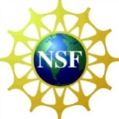

Friday October 19th

8:00 Continental Breakfast: Networking

9:00 Econ Env Principles Greg Characklis
Unniversity of North Carolina

Incorporating sustainability/life-cycle Erica McKenzie and Desiree Plata
UC Davis and Duke University

10:00 Break

10:30 Incorporating climate change in Jeff Cunningham
Gen - EnvEng education University of South Florida

Educating dynamics in water distribution Young Seo
University of Toledo

Back to our roots: Public Health Joel Burken and Heather Henry
Missouri S&T and NIEHS

12:00 Discussions: Incorporating new topics Everybody!

12:30 Lunch Working

1:30 Concept Inventory for Introductory Sukalyan Sengupta (Ergas/Cunningham/Goel)
Environmental Engineering Courses University of Massachusetts Dartmouth

Teaching Collaboratory Nancy Kinner (Masten/Parker/Weaver)
University of New Hampshire

Sharing Next Generation Env Eng Edu Claudia Gunsch/Kaitlin Mallouk/JG Burken
Duke/Illinois/Missouri S&T

3:00 Breakout on Deliverables

3:30 Sharing and Recommendations for 2013

5:30 Social and dinner for those staying Morgan Street Brewery

Registration at: http://aeespfrontiers.mst.edu/
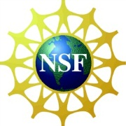
Lodging at Hyatt Regency Gateway: Make Hotel Room Reservations Now
Use Code: “Missouri S&T: AEESP Frontiers” Room Block open through Sept 26th
Reserve your Hotel Room Online or Call: 888-421-1442
The conference is supported through grants from the National Science Foundation and the National Institute of Environmental Health Sciences. Without this support the conference organization would not have been as successful. We are greatly indebted to NSF and NIEHS, particularly Debbie Reinhart and Paul Bishop at NSF and Heather Henry at NIEHS.

